Ideation Phase
Empathize & Discover
Date | 27-09-2026
Team ID | SWTID-2026-5541
Project Name | AI-FitTrack
Maximum Marks

Empathy Map Canvas:

An empathy map is a simple visual tool that helps the team understand users’ thoughts, feelings, actions, and needs. It supports FitTrack in understanding the everyday experiences of people who want to build healthy habits and track their fitness progress.
By considering what users say, think, do, and feel, the team can identify their challenges and motivations. This helps shape a fitness-tracking experience that is clear, practical, and easy to use.
Example:
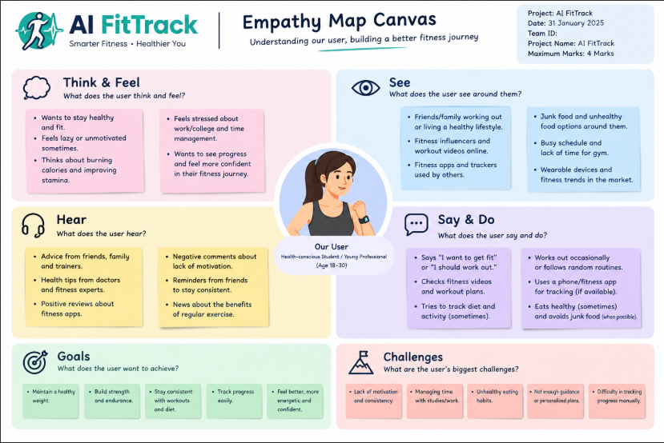

Reference: https://www.mural.co/templates/empathy-map-canvas
Example: FitTrack – Fitness Tracking Application
THINK & FEEL  “I want to stay active, but I need motivation.” | HEAR  Friends recommend walking and regular exercise. | SEE  Daily steps, reminders, and progress summaries.
SAY & DO  Sets a weekly goal and logs workouts when possible. | PAIN  Missed logs make progress difficult to understand. | GAIN  A simple tracker helps build consistency and confidence.

